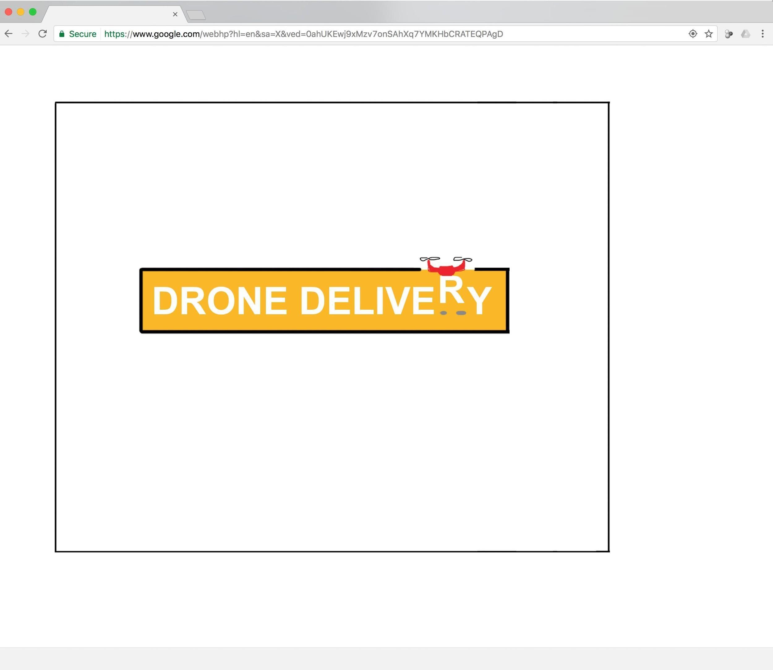

**Drone Delivery Progress Update:**

The game is starting to improve! We have added the following features and changes:

Features

* Course 1’s walls, Drone, Package, and Drop Zone location have been finalized and added
* Game timer has been added, visualization of game timer has been added
* Game timer events has been added (when run out of time signals end of course, when have 10 seconds remaining the time visualization turns red)
* A start screen has been added to the game and animated to fade out
* Explanation of gameplay was added
* Game startup now pauses after building level and displaying gameplay explanation, requires spacebar to start game
* The Drone’s propeller animation has been revised to move slowly and continuously when Drone isn’t flying, and to increase in speed when Drone is flying
* Drop Zone includes text

Technical

* Added constants to control wave animation and course 1 time limit
* Game initialization has been reformatted to allow for the addition of multiple courses
* Wall creation method, Drop Zone creation method have been revised with parameters to indicate location
* Improved organization of code base
* Created course over method to handle all end course events

**Credits / Backlog**

D: Drone P: Package O: Objects PP: Power pack GUI: GUI G: Gameplay C: Code

|  |  |  |  |  |
| --- | --- | --- | --- | --- |
| **Item** | **Phase** | **Type** | **Responsible** | **Done?** |
| **(by February 13)**  **Design course with wall, drop zone, ocean, platforms, The Package, and Drone, drop zone, hazard events functional, collision detection, movement controls functional for both package and Drone, ability to pause the game, add Container design** | **1** | **-** | **together** | **X** |
| Add ability for drone to pick up objects | 1 | D | Ryan | X |
| Add Collision Detection (drone) with game objects, game frame | 1 | D | Ryan | X |
| Add Drone movement controls | 1 | D | Ryan | X |
| Add interaction b/w drone and hazards | 1 | D | Jack | X |
| Add interaction b/w package and hazards | 1 | D | Jack | X |
| Animate Drone propellers | 1 | D | Ryan | X |
| Design Drone, add to game | 1 | D | Ryan | X |
| Add drop zone event | 1 | G | Jack | X |
| Add pause text | 1 | GUI | Jack | X |
| Add end-course event (Drone or Package hit hazard) | 1 | G | Jack | X |
| Add pause functionality | 1 | G | Ryan | X |
| Add background as bitmap | 1 | O | Ryan | X |
| Design container, add to game | 1 | O | Ryan | X |
| Design Drop Zone, add to game | 1 | O | Jack | X |
| Design Game background | 1 | O | Ryan | X |
| Design Ocean, add to game | 1 | O | Ryan | X |
| Design Wall and floor, add to game | 1 | O | Ryan | X |
| Add Collision Detection (Package) | 1 | P | Ryan | X |
| Add Package movement ability (independent of drone / dependent on drone) | 1 | P | Ryan | X |
| Design The Package, add to game | 1 | P | Ryan | X |
| Determine mechanics for how package relates to drone (move with drone, move independent of drone and can be dislodged) | 1 | P | Together | X |
| Animate Ocean (water movement / waves) | 1 | O | Ryan | X |
| **(by Feb 22)**  **Design course with Flock-of-Birds, animate Flock-of-Birds movement, include ability to start new game from paused situation or after losing the course, add a game timer, improve JS functions** | **2** | **-** | **together** |  |
| Add “new game” space bar functionality to pause screen | 2 | G | Jack |  |
| Design Flock-of-Birds, add to game | 1 | O | Jack |  |
| Revise in-game pause menu / text | 2 | GUI | Jack | X |
| Add game timer functionality | 2 | G | Ryan | X |
| Add game timer visualization | 2 | GUI | Ryan | X |
| Animate Flock-Of-Birds (fly side to side) | 2 | O | Jack |  |
| Implement generic wall creation method | 2 | O | Ryan | X |
| Add end-course event (timer runs out) | 2 | G | Ryan | X |
| **(by Feb 27)**  **Design course with sprites, end-course events of running out of time, improve the GUI for the user** | **3** | **-** | **together** |  |
| Add Game Start Screen | 3 | GUI | Ryan | X |
| Improve Drone propeller design and animation | 3 | D | Ryan | X |
| Add end-course/ end-game notification popup in-screen, pauses game after winning or being destroyed | 3 | GUI | Jack | X |
| Add level number visualization | 3 | GUI | Jack |  |
| Add paused game text at beginning of each course | 3 | GUI | Jack | X |
| Add explanation of gameplay / goal at beginning of game | 4 | GUI | Ryan | X |
| Design Sprites, add to game | 3 | O | Jack |  |
| **(by March 6)**  **Add course where all animations are implemented, start screen added, explanation of gameplay, course 1 is fully designed (all game objects in place)** | **4** | **-** | **together** |  |
| Improve differentiation of movement of drone and package, such as:   * drone moves faster when flying upward * package retains same horizontal speed when dropped from drone * drone moves slower when carrying the package than otherwise | 4 | D | Ryan |  |
| Diagram the functions and relationships of the code | 4 | C | Ryan |  |
| Add comments and description to code | 4 | C | Ryan |  |
| Add comments to code | 4 | C | Jack |  |
| Add Sprite animation to game | 4 | O | Jack |  |
| Design Sprite animation | 4 | O | Jack |  |
| **(March 6, 8, 10)**  **Present finished Course 1 with all features** | **5** | **-** | **Together** |  |